# Exp2 Controlling Execution

**1 Experiment purpose**

Through this training, to master and be familiar with the programming environment of Java language. Run a Java program; the students master the Java language data types, operators and expressions and other basic content. Understand the precedence of operators.

**2 Development Environment**

1. Notepad++
2. JDK 8+

**3 Content and Steps**

**Problem 1:** Point in a circle?

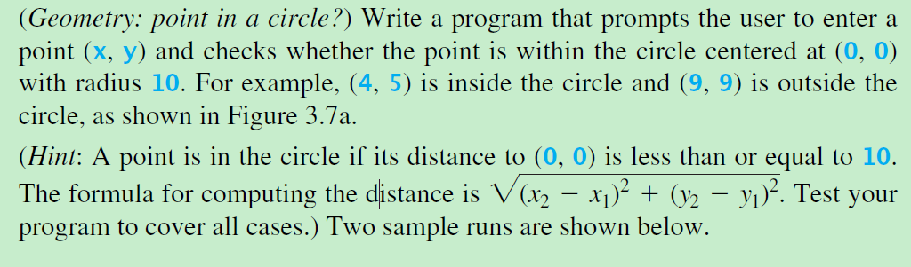

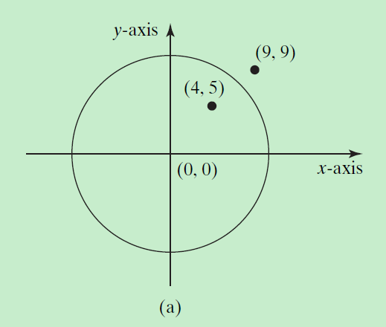

**Steps:**

(1) Define the main class.

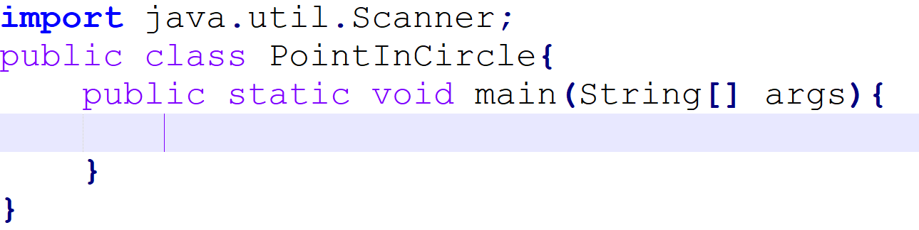

(2) The *while* structure keep the program running.

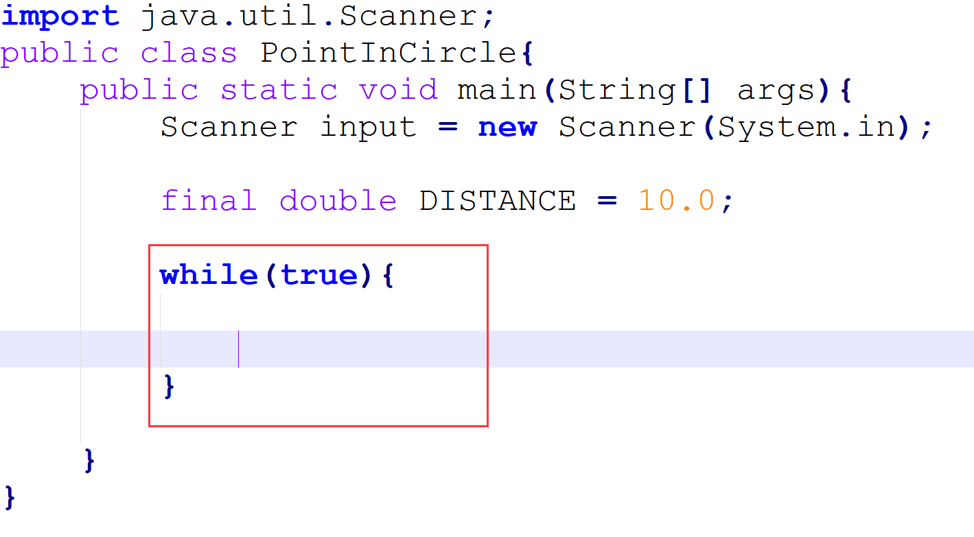

(3) Complete the business code.

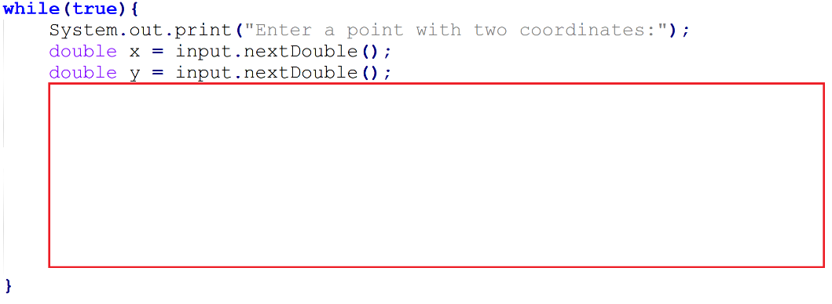

**Problem 2:** Solving linear equations

(*Game: scissor, rock, paper*) Write a program that plays the popular scissor-rockpaper game. (A scissor can cut a paper, a rock can knock a scissor, and a paper can wrap a rock.) The program randomly generates a number **0**, **1**, or **2** representing scissor, rock, and paper. The program prompts the user to enter a number **0**, **1**, or **2** and displays a message indicating whether the user or the computer wins, loses, or draws. Revise the program to let the user continuously play until either the user or the computer wins more than two times than its opponent.



The expected result:

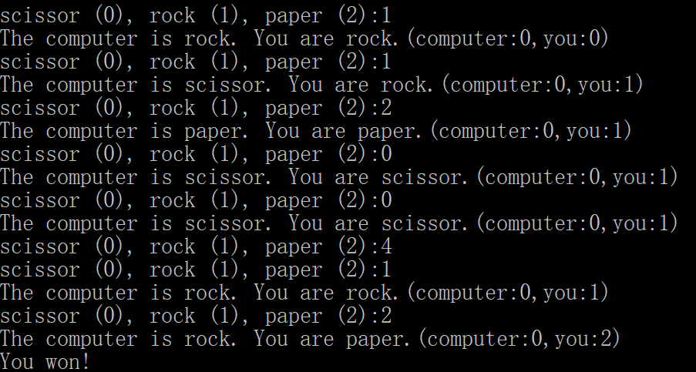

**Steps:**

(1) Define the main class and import the class *Scanner*.

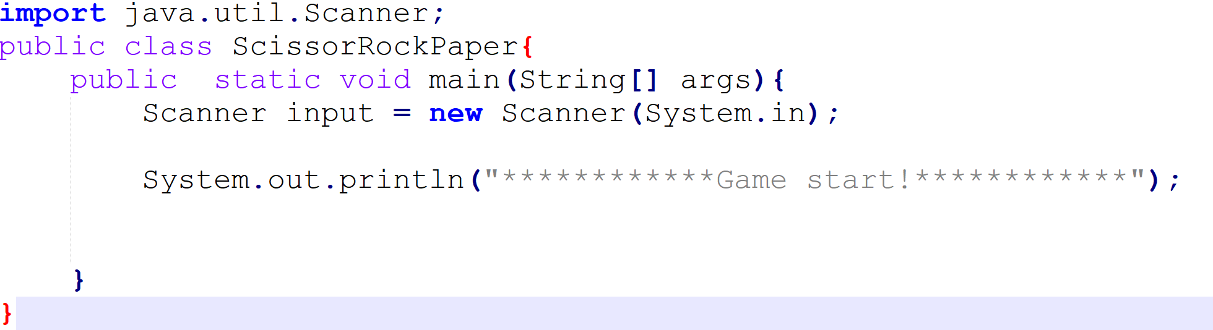

(2) Use two variables to record wins.

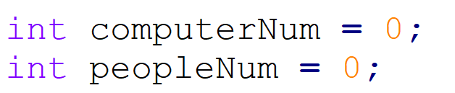

(3) Use string array store the three selections.



(4) How to play with computer.

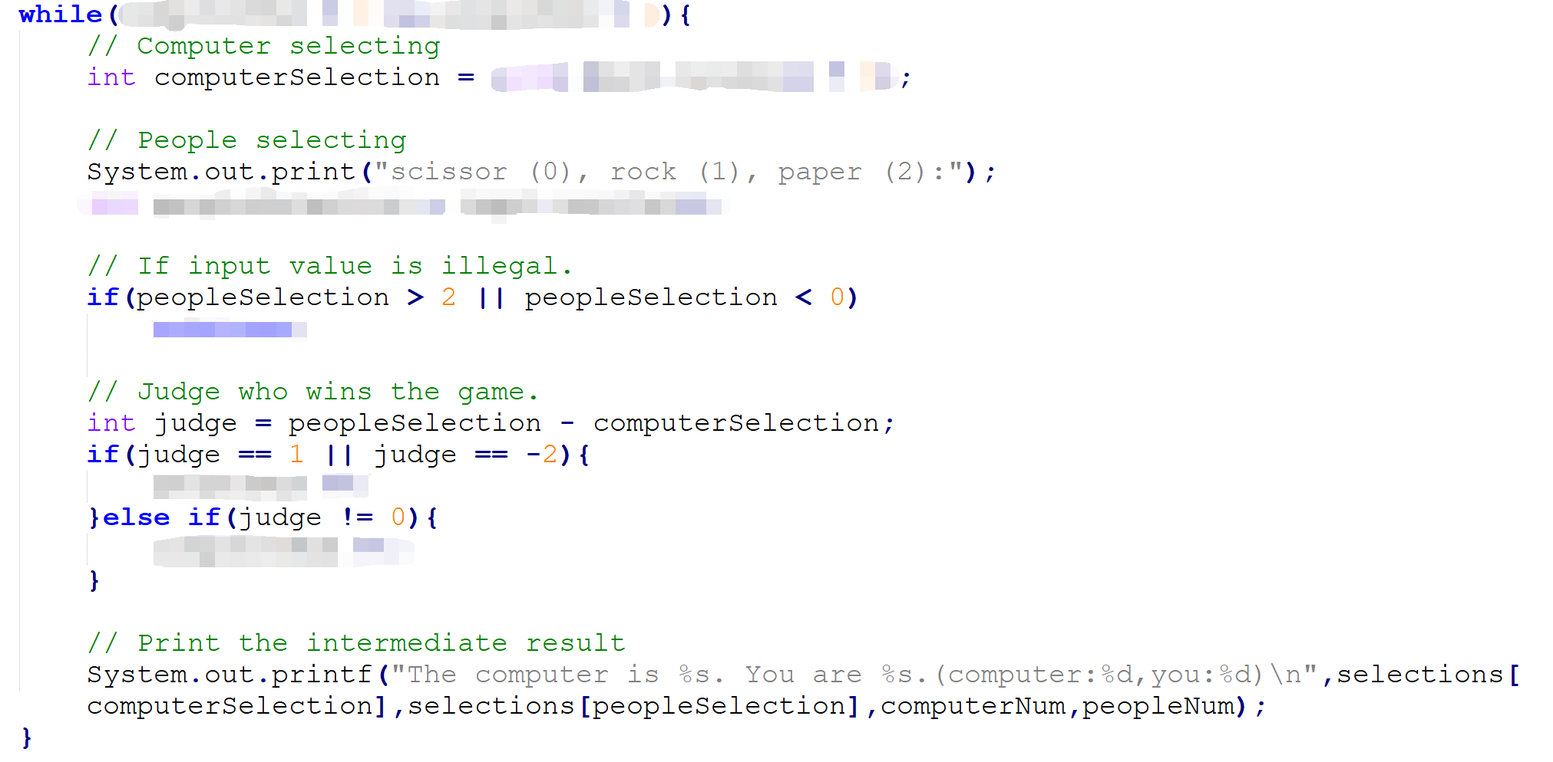

(5) Print the game result.

